1. Tool

*Excel, SQL*

1. Procedge:
   1. Use SQL to check all the cities and export the temperature information of the nearest city, Shanghai and the globe.

*SELECT \**

*FROM city_list*

*ORDER BY country*

*SELECT \**

*FROM city_data*

*WHERE city='Shanghai'*

* 1. How to visualize the temperature plot

*The temperature information is visualized below with two lines indicated average temperature for the globe in yellow and for Shanghai in red. The area parts shows the percentage of the temperature increase from 1841.*

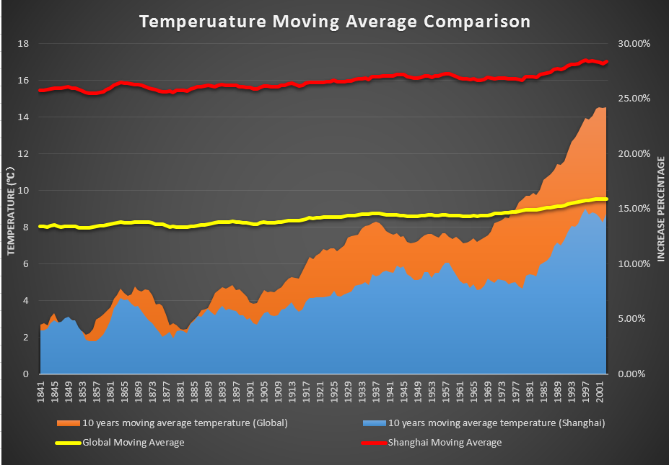

* 1. How to calculate the moving average

*The moving average is calculated as the average for 10 years. The equation is illustrated in the figure below for all the values in this column . It is applied for the average temperature in Shanghai and for globe. Besides, the percentage of the temperature increase is also applied with 10 years moving average equation.*

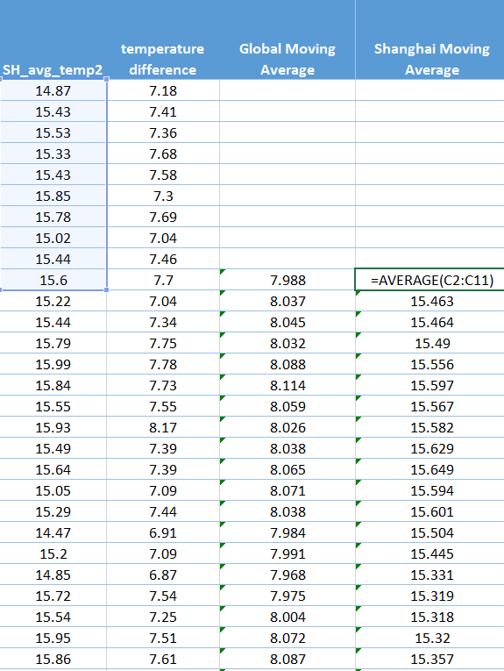

* 1. What are the main concerns to visualize the plot?

1. *The clear comparison between the average temperature in Shanghai and in globe*
2. *The trend of the average temperature from 1841 to 2013*
3. *The increasing rate of the average temperature in Shanghai and in globe*
4. *Clear presentation for each line and area*
5. Conclusion
6. Which is warmer, average temperature in Shanghai or in globe?

*The average temperature is higher in Shanghai compared to globe one.*

1. What is the different/similar part of the temperature trend between the globe and Shanghai?

*The temperature trends both for the globe and Shanghai are increasing. The increasing rate are similar, but the average temperature for the globe grows faster than it for Shanghai.*

1. What about the long-term trend of the global average temperature? The global temperature is becoming warmer or colder? Is the trend the same with the pass hundreds of years?

*From observation of the data from 1841, the future expectation for the average temperature is still increasing. The global temperature will become warmer.*